**VPLIV URBANIZACIJE NA GOZDNI EKOSISTEM**

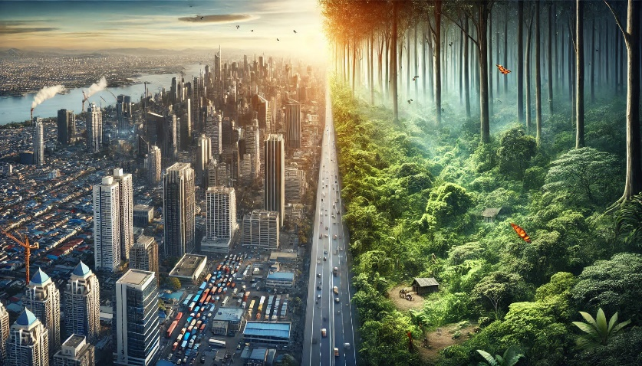  
Slika 1: Vpliv urbanizacije (VIR: Copilot)

GOZD ali MESTO?

SONČNA SVETLOBA ali JAVNA RAZSVETLJAVA?

GOZDNE ŽIVALI, RASTLINE ali AVTOMOBILI?

Katero dobrino bi izbrali raje? Večina ljudi bi se najverjetneje odločila za drugo. Kaj pa, če vprašanje zastavimo drugače? Kako bi se počutili, če gozda ne bi bilo nikjer na svetu? Povsod le sivina, ceste, avtomobili, tovarne, trgovine, stavbe …   
To je srhljiva podoba sveta, ki ni možna le v filmih, temveč postaja resničnost, saj se gozd, edini zeleni kotiček na naši Zemlji, spreminja v črno-bele fotografije. Kdo je krivec? Smo to egoistični ljudje, ki bi v današnjem svetu raje izbrali napredek in razvoj namesto neokrnjene narave?

Število prebivalstva na Zemlji se je v zadnjem pol stoletja podvojilo, svoje ozemlje širimo neomejeno, pri tem pa posegamo tudi v naravo. Številni ljudje so se zaradi možnosti boljše zaposlitve, izobraževanja, dostopa do zdravstva, iz podeželja selili v mesta, zato se je povečala gradnja novih, vedno večjih in sodobnejših stavb, kar je povzročilo pomanjkanje prostora. Ljudje so začeli izsekavati gozdove in na teh ozemljih širili infrastrukturo, povečevali gospodarsko dejavnost z gradnjo novih tovarn, koncentriranjem trgovin in storitvenih dejavnosti. Vse našteto lahko strnemo v pomemben družbenoekonomski pojav, ki ga imenujemo urbanizacija. Ta spremlja razvoj človeške civilizacije že od začetka industrijske revolucije naprej.

Urbanizacija je prinesla številne, tako pozitivne kot negativne posledice. V gozdovih je povzročila zmanjšanje biotske raznovrstnosti, ponekod celo upad in izumrtje nekaterih vrst. Srečujemo se tudi z ostalimi problemi, kot so: fragmentacija gozda, erozija in degradacija tal ter celo spreminjanje podnebja in temperature. Več ljudi posledično pomeni več odpadkov, odpadnih vod, strupenih izpušnih plinov … Sodobna mesta hrupa, svetlobe, avtomobilov, v katerih življenje teče podnevi in ponoči, močno prispevajo k onesnaževanju prsti, zraka, vode in negativno vplivajo na gozdove, zdravje rastlin in živali v njem.

Vpliv urbanizacije je opazen predvsem na območjih večjih mest, ki so strnjena v megalopolis. Žal pa je njen vpliv prisoten tudi v lokalnem okolju. Vedno več ljudi si želi bivati v mirni okolici, svežem zraku, čisti naravi, zato se vračajo v ruralna okolja, v zeleno Kočevsko, kjer smo iz teh razlogov pozidali že kar nekaj gozdnih površin. Tudi za potrebe rekreacije namesto cestnih, asfaltiranih površin uporabljamo zelene gozdne poti. Nimamo meja, zahajamo na neutrjene in neoznačene poti, uničujemo prst, rastline in motimo mir živali. Vlake, namenjene gozdni proizvodnji, uporabljamo za sproščanje adrenalina in dirke z avtomobili, štirikolesniki in kros motorji. Industrijo širimo na najbolj rodovitnih območjih, razvijamo tudi industrijsko cono s podjetji, kot so Yaskawa, Dinos in nekateri drugi.

Urbanizacija ima številne negativne posledice in predstavlja grožnjo gozdnemu ekosistemu. S svojimi nepremišljenimi dejanji močno škodujemo naši še neokrnjeni naravi. Odločiti se moramo, ali bomo dali prednost svojemu egoističnemu vedenju, gledali le na lastne potrebe, ali pa bomo poiskali način, kako sobivati z naravo, saj nam ta omogoča življenje in jo skušali ohraniti ter zavarovati.

VIRI:

* Tomassini, Jeršin, Kristijan, Serša, Kralj, Marjana in Lea, Nemec, 2015: Geografija 1: i-učbenik za geografijo v 1. letniku gimnazij. Ljubljana: Zavod RS za šolstvo. [Citirano 9. januarja 2025; ob 12. 10.] Dostopno na spletnem naslovu: <https://eucbeniki.sio.si/geo1/2537/index.html>
* Wikipedia.org (2025). Urbanizacija. [Online]. Čas zadnje spremembe: 20. april 2023; 12:37. [Citirano 9. januarja 2025; 13:15]. Dostopno na spletnem naslovu: <https://sl.wikipedia.org/wiki/Urbanizacija>

Ula Robida in Meta Lončarevič, 3. b

**IMPACT OF URBANIZATION ON THE FOREST ECOSYSTEM**



Photo 1: Impact of urbanisation (SOURCE: Copilot)

FOREST or CITY?

SUNLIGHT or STREET LIGHTING?

FOREST ANIMALS, PLANTS or CARS?

Which commodity would you rather choose? Most people would probably choose the second option. But what if the question is asked differently? How would you feel if there were no forests anywhere in the world? Everywhere just greyness, roads, cars, factories, shops, buildings...

This is a terrifying image of a world which is not only possible in movies but is becoming a reality, as the forest, the only green corner on our Earth, is being transformed into black and white photographs. Who is to blame? Selfish people who would rather choose progress and development over untouched nature?

In the last half century, the population of people on Earth has doubled. We have already expanded our living space beyond limits, thus hugely intervening with nature. Many people have moved from the countryside to the cities for the possibility of better employment, education, access to health care… That is why the construction of new, larger and more modern buildings has increased, resulting in a lack of space. People have been cutting down forests and expanding infrastructure in deforested territories, increasing economic activity by building new factories, concentrating shops and service activities. All of this can be summed up in an important socio-economic phenomenon called urbanization. It has been tracking the development of human civilization since the beginning of the Industrial Revolution.

Urbanization has brought both positive and negative consequences. It has led to a reduction of biodiversity in forests, in some cases even the decline and extinction of some species. We are also facing other problems, such as forest fragmentation, erosion, soil degradation and even climate and temperature change. If there are more people, it means there is more waste, wastewater, toxic exhaust gases and so on. Modern cities full of noise, lights, cars, where life runs day and night, contribute greatly to pollution of air and water. They also negatively affect forests and the health of plants and animals in them.

The impact of urbanization is noticeable especially in the areas where bigger cities merge into megalopolis. Unfortunately, its impact is also present in our local environment. More and more people want to live in peaceful surroundings, untouched nature and breathe fresh air. They return to rural environments, to the green Kočevsko, where we have already built up quite a few former forest areas. Also, for recreation purposes we use green forest paths instead of roads and asphalt surfaces. We have no boundaries, we walk off the beaten track, on unmarked paths, destroying forest ground, plants and disturbing the peace of animals. Skidtrails intended for forest production are used to release adrenaline by driving a car, four-wheelers and for cross-country motorcycle races. We are expanding the industry in the most fertile areas and we are also developing an industrial zone with companies such as Yaskawa, Dinos and some others.

Urbanization has brought many negative consequences and poses a threat to the forest ecosystem. With our thoughtless actions, we are greatly harming our currently pristine nature. We have to decide whether we will prioritize our self-interested actions and look only at our own needs, or we will find a way to coexist with nature. Nature enables our existence and that is why we have to try to preserve and protect it.

SOURCES:

* Tomassini, Jeršin, Kristijan, Serša, Kralj, Marjana in Lea, Nemec, 2015: Geografija 1: i-učbenik za geografijo v 1. letniku gimnazij. Ljubljana: Zavod RS za šolstvo. [Citirano 9. januarja 2025; ob 12. 10.] Dostopno na spletnem naslovu: <https://eucbeniki.sio.si/geo1/2537/index.html>
* Wikipedia.org (2025). Urbanizacija. [Online]. Čas zadnje spremembe: 20. april 2023; 12:37. [Citirano 9. januarja 2025; 13:15]. Dostopno na spletnem naslovu: <https://sl.wikipedia.org/wiki/Urbanizacija>

Ula Robida in Meta Lončarevič, 3. B