**PRIHODNOST KMETIJSTVA V TEHNOLOGIJI**

Trenutno živimo v najbolj pomembni dobi agrikulturnega razvoja v zgodovini človeštva, saj se dogaja revolucija, revolucija, ki bo popolnoma spremenila način svetovne pridelave hrane s pomočjo najnaprednejših tehnologij kot npr., umetna inteligenca, roboti in genski inženiring. Vse pogostejša je uporaba samovozečih traktorjev, laserjev za odstranjevanje plevela, dronov za pobiranje pridelka in mnogo drugih inovacij... Ampak zakaj?

Življenjski standard povprečnega človeka se dviga, število ljudi hitro raste, potrebe ljudi se povečujejo, okolje pa ostaja enako. Vse to vodi v pretirano uničevanje in podrejanje okolja potrebam ljudi, kar ima dolgotrajne negativne posledice za vso živo naravo planeta Zemlje. Ljudje potrebujemo za preživetje hrano, kar pa ni majhna potreba, saj je trenutno na planetu pribl. 8 milijard ljudi in zato kmetijstvo z vsakim trenutkom postaja bolj pomembno. Trenutne kmetijske tehnike niso dovolj trajnostno naravnane, saj neposredno slabo vplivajo na okolje na več načinov, hkrati pa se z eksponentno rastjo potreb ljudi stopnjuje tudi inteziteta negativnih vplivov na okolje.

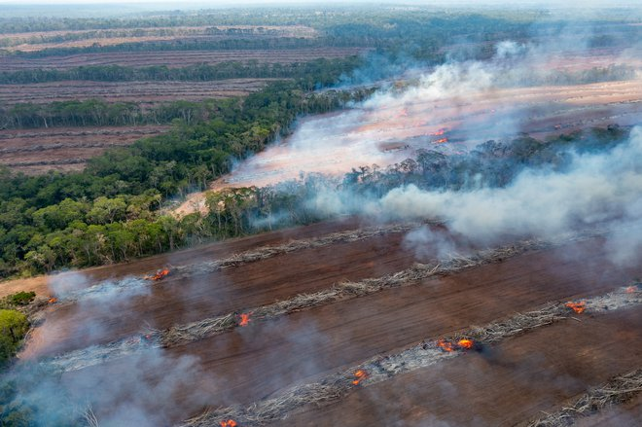

* **DEFORESTACIJA**

je postopek krčenja gozda s tehniko goloseka za namene pridobivanja novih kmetijskih površin (80 %) ali stanovanjskih in prometnih površin (20 %).

* **IZGUBA HABITATA**

Slika 1: Deforestacija: (<https://shorturl.at/CjvcO>)

je posledica deforestacije. Zaradi krčenja gozdov, ki nudijo življenjski prostor mnogim živalim, so te primorane zapustiti te prostore in zato pogosto ne preživijo.

* **IZGUBA RODOVITNOSTI ZEMLJE**

je posledica intenzivnega kmetovanja velikih kmetij, ki pridelajo zelo veliko količino rastlinske hrane in pogosto sadijo večkrat letno na istih obdelovalnih površinah. To izčrpa zemljo, rastline vsakokrat znova za rast potrebujejo hranila in minerale iz prsti, le-teh pa čez čas preprosto zmanjka. Takšna prst postane pusta in nerodovitna.

* **ONESNAŽENJE S PESTICIDI IN GNOJILI**

je posledica pogoste uporabe pesticidov in gnojil pri pridelavi poljščin, kar je značilno za velike kmetije in agrikulturna podjetja, ki želijo povečati pridelek. Umetno narejeni pesticidi in gnojila vsebujejo mnogo umetnih snovi in strupov z namenom obvarovanja pridelka pred škodljivci in okoljem, posledično pa imajo negativen vpliv na okolje. Pri uporabi pesticidov in gnojil lahko pride do trajne onesnaženosti vode in prsti, kar pa posledično vpliva na druge žive organizme.

Seveda se vpliv kmetijstva na ekosisteme razlikuje glede na kmetijsko tehniko, glede na to kaj pridelujemo, katere pesticide in gnojila uporabljamo, glede na velikost obdelovalne površine, vrsto strojev, ki jih uporabljamo pri obdelovanju ipd. V Sloveniji je zelo malo negativnih vplivov kmetijstva. Glavna problematika kmetijstva v Sloveniji je fragmentacija naravnega okolja, ki je prisotna tudi v lokalnem okolju. Do fragmentacije pride, ko je določeno gozdno območje najpogosteje prekinjeno zaradi širjenja kmetij ali urbanizacije. Živalim tako preprečimo prost prehod med gozdovi, kar pa negativno vpliva na gozdove in sam ekosistem.

Znanstveniki menijo, da moramo poiskati bolj trajne in okolju prijazne načine pridelovanja hrane, saj so vplivi kmetijstva na okolje povečujejo z rastjo prebivalstva. Rešitev se skriva v tehnologiji.

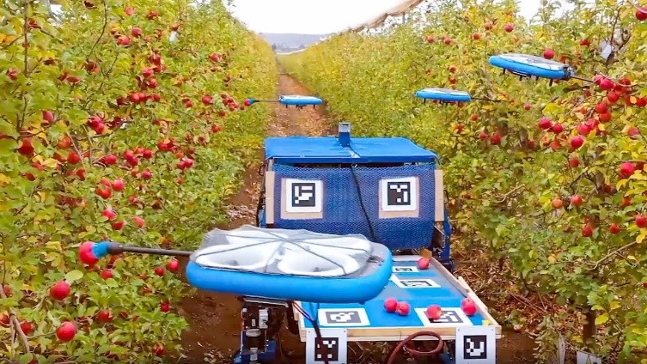

* **UPORABA KMETIJSKIH DRONOV** za spremljanje pridelkov iz zraka je že pomagala številnim kmetom po svetu izboljšati njihovo produktivnost.

Slika 2: Uporaba dronov v kmetijstvu: (<https://shorturl.at/pCm1r>)

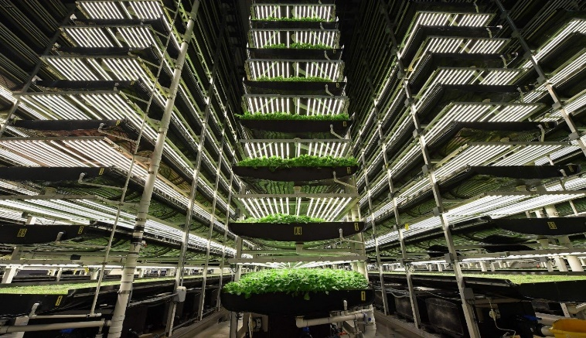

* 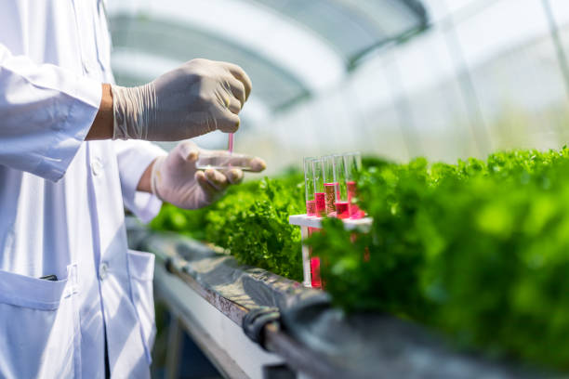**PODZEMNO KMETIJSTVO** omogoča večjo trajnost in učinkovitost pridelave hrane, saj zmanjšuje potrebo po obdelavi površinskih tal in omogoča večjo izrabo omejenih prostorov v urbanih območjih. Hkrati prispeva k zmanjšanju vpliva kmetijstva na okolje, kot so erozija tal, izguba biotske pestrosti in onesnaževanje tal ter vodnih virov.

Slika 3: Podzemna galerija pridelkov: (<https://shorturl.at/IJZMj>)

* **GENSKI INŽINIRING** v kmetijstvu vključuje spreminjanje genetske sestave rastlin in živali, da bi izboljšali njihove lastnosti, kot so odpornost na bolezni, večja pridelava in prilagodljivost na okoljske razmere.

Slika 4: Uporaba genske tehnologije: (<https://shorturl.at/VhXhY>)

**VIRI**

* Maglio, Nicola. (2023). Agruculture – Why The Next Revolution Is Now. [Datum zadnjega popravljanja 26. januar 2023]. [Citirano 16. januar 2025; 12:40]. Dostopno na spletnem naslovu:

<https://www.greenforges.com/blog/agriculture-why-the-next-revolution-is-now>

* Nunez, Christina. (2022). Why deforestation matters—and what we can do to stop it. [Datum zadnjega popravljenja 7. december].[Citirano 16. januar 2025; 12:48]. Dostopno na spletnem naslovu: <https://www.nationalgeographic.com/environment/article/deforestation/>

Avtorja: Jan Strle, Jan Mihelič

**THE FUTURE OF AGRICULTURE IS IN TECHNOLOGY**

(The impact of agriculture on the forest ecosystem)

Currently we are living in the most important era of agricultural advancements in the history of mankind and that is beacuse of an ongoing revolution, a revolution which is said to have the ability of changing the world production of food with the use of advanced technologies, such as artificial intelligence, robots and genetic engineering. Implementation of selfdriving tractors, lasers for disposal of weeds, drones for harvesting and many more technologies is becoming more and more common in agriculture. But why?

An average person`s living standard is rising, the number of people is on the rise, the needs of people are increasing, but the environment remains the same. All this leads to excessive destruction and submission of the environment to the needs of humans, which has long-lasting negative consequences on all animate nature of the planet Earth. Humans need food in order to survive, but this is not a small need considering the fact that there are 8 billion of us, which is also the reason why the imporatnce of agriculture is growing. Current farming techniques are not sustainable enough, because they negatively affect the environment in many different ways. As people's needs are exponentially rising, the negative effects of agriculture are intesifying and escalating.

* **DEFORESTATION**

is a pocedure of shrinkage of forests with the use of clearing techniques, for the purpose of creating new agricultural land or even for creating residential urban areas. The most common goal of deforestation is creating space for agricultural needs, which globally represents almost 80% of all deforestation.

* **HABITAT LOSS**

Picture 1: Deforestation: (<https://shorturl.at/CjvcO>)

is a consequence of deforestation. As forests offer a habitat to many animals, the forest shrinkage results in habitat loss. Many animals are forced to leave their natural environments, thus risking their survival.

* **LOSS OF SOIL FERTILITY**

is a consequence of intensive farming on big farms, which produce a lot of plant based food and plant seeds on the same ground surfaces many times a year. This technique exhausts the soil as plants need new minerals and nutrients to enable their growth, but the amount of these substances in the soil is not unlimited. When they get depleted by the plants and there are no more left, the soil becomes barren and infertile.

* **POLLUTION BY PESTICIDES AND FERTILIZERS**

is a consequence of a frequent use of pesticides and fertilizers in crop production, which is characteristic of large-scale farmers and agricultural practices aiming to increase yields. Artificially produced pesticides and fertilizers have a negative impact on the environment. They contain many synthetic substances and toxins designed to protect crops from pests and environmental factors. The use of pesticides and fertilizers can lead to long-term contamination of water and soil, which consequently affects other living organisms.

Of course, the impact of agriculture on ecosystems varies depending on agricultural techniques, the type of crops grown, the pesticides and fertilizers used, the size of the cultivated area, the type of machinery employed, and more. In Slovenia, the negative impacts of agriculture are not yet noticeable because there are not that many cultivated areas, however in the future this might change if a higher proportion of food self-supply is to be achieved. At present the proportion of fruit and vegetable self-supply in Slovenia is less than 50%. If Slovenia wanted to achieve self-sufficiency, the surface of cultivated areas would have to double, mainly at the expense of forested areas. Currently the main problem of agriculture in Slovenia is fragmentation of the natural environment, which is also present at our local level. Fragmentation occurs when a forested area is disrupted due to the expansion of farms or urbanization. This prevents animals from moving freely between forests, which negatively affects the forests and the ecosystem as a whole. The most common examples of such disruptions in our local environment are fenced off pastures and meadows.

Scientists therefore believe that we need to find more sustainable and environmentally friendly ways of producing food as the negative environmental impacts of agriculture are increasing with the population growth. The solution lies in technology.

* **THE USE OF AGRICULTURAL DRONES** for monitoring crops from the air has already helped many farmers around the world improve their productivity.

Picture 2:The use of drones in farming: (<https://shorturl.at/pCm1r>)

* **UNDERGROUND FARMING** enables greater sustainability and efficiency in food production by reducing the need for surface soil cultivation and allowing better utilization of limited spaces in urban areas. At the same time, it helps mitigate agriculture's environmental impact, such as soil erosion, biodiversity loss, and pollution of soil and water sources.

Picture 3:Underground farming: (<https://shorturl.at/IJZMj>)

* **GENETIC ENGINEERING** in agriculture involves altering the genetic makeup of plants and animals to enhance their traits, such as disease resistance, higher yield, and adaptability to environmental conditions.

Picture 4: The use of gene technology: (<https://shorturl.at/VhXhY>)

**SOURCES**

* Maglio, Nicola. (2023). Agruculture – Why The Next Revolution Is Now. [Last edited: 26th of january 2023]. [Cited 16th january 2025; 12:40]. Accsessible on the internet:

<https://www.greenforges.com/blog/agriculture-why-the-next-revolution-is-now>

* Nunez, Christina. (2022). Why deforestation matters—and what we can do to stop it. [Last edited: 7th of december].[Cited: 16th of january 2025; 12:48]. Accsessible on the internet:

<https://www.nationalgeographic.com/environment/article/deforestation/>

Authors: Jan Strle, Jan Mihelič