**TUJERODNE VRSTE DREVES IN ZELIŠČ**

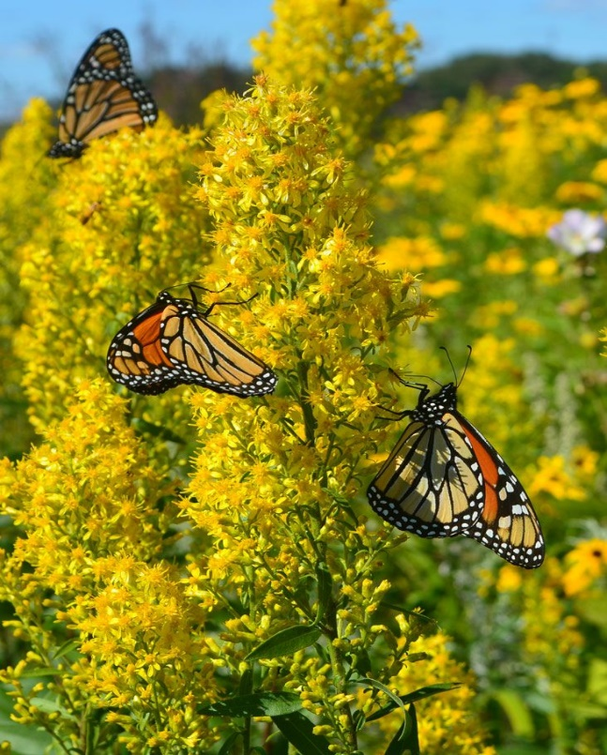

Slika 1: *Solidago speciosa*

(vir: https://www.pinterest.com/pin/260645897179468650/)

Ste se kdaj jeseni ozrli naokoli in opazili, da nekatere rastline še vedno cvetijo? Ali ne bi bila jesen lepša in barvitejša, če bi cvetelo še več rastlin? Če ste velik oboževalec barvite, pravljične jeseni, vam lahko namigneva, da gre za rastline, ki škodujejo tako okolju kot ljudem.

Tujerodne vrste so organizmi, ki jih je človek prenesel v novo okolje, v katerem prej niso bili prisotni. Večina ljudi se ne zaveda problematičnosti tujerodnih vrst, saj so zanje to samo barvite rastline, ki »lepšajo« naše okolje. Vendar se moramo zavedati, da lahko tujerodne vrste postanejo težava, saj lahko postanejo invazivne ne le za avtohtone rastline, temveč tudi za nas, ljudi.

Tujerodne vrste ljudje naseljujejo namerno in nenamerno. Nekatere tujerodne vrste je človek naselil z namenom, da bi se vrste v okolju tudi ustalile, človek pa bi imel od njih določeno korist. V Sloveniji še vedno prihaja do nezakonitih namernih naselitev tujerodnih vrst v naravo. Rastline, ki jih nenamerno prepeljemo s transportnimi sredstvi, embalažo ali osebno prtljago, imenujemo kar slepi potniki, saj potujejo skriti in pogosto uidejo nadzoru na mejah. Te rastline niso nujno nezakonite same po sebi, vendar pa lahko njihov prenos, ki ni skladen z zakonodajo ali predpisi, pomeni nezakonito dejanje. Najbolj znane tujerodne vrste na Kočevskem so kanadska zlata rozga, žlezava nedotika, japonski dresnik, pelinolistna žvrklja in enoletna suholetnica.

Invazivne vrste lahko odstranimo na več načinov. Najpogostejši so fizično, biološko in kemično odstranjevanje. Pri fizičnem odstranjevanju rastlino preprosto izvlečemo iz zemlje, slabo je le to, da je tak postopek lahko dolgotrajen in naporen.

Pri biološkem odstranjevanju uporabimo naravnega plenilca invazivnih vrst, da iz okolja odstranimo prvotno invazivno vrsto. Ta pristop je lahko zelo tvegan, saj lahko naravni plenilci postanejo invazivne vrste. Vnos druge invazivne vrste samo zato, da bi odstranili prvotno invazivno vrsto, ni samo tvegan, ampak lahko povzroči še več težav.

Zadnji način odstranjevanja invazivnih vrst je kemično odstranjevanje. Pri kemičnem odstranjevanju uporabljamo pesticide za odstranjevanje invazivnih vrst. Pri uporabi kemikalij moramo biti previdni, da ne povzročimo več težav v okolju, saj je lahko uporaba prevelikih količin pesticidov nevarna.

Invazivne vrste lahko postanejo težava ne le za domorodne rastline, temveč tudi za ljudi. S kupovanjem in nasajanjem tujerodnih vrst lahko še bolj ogrozimo domorodne rastline. Tujerodne vrste izpodrivajo domorodne rastline, saj zavzemajo njihov habitat, posledično pa tudi zavzemajo njihovo hrano in vodo. Zaradi velike »tekmovalnosti« tujerodnih vrst, lahko propade veliko rastlin. Pomembno je, da iz tujine ne prinašamo neznanih vrst, saj lahko postanejo invazivne ali pa lahko prenašajo različne bolezni, ki se lahko razširijo tudi na ljudi.

VIRI IN LITERATURA:

* Kus Veenvliet, Jana, Veenvliet, Paul. (2017) Način naselitev tujerodnih vrst. [Datum zadnjega popravljanja december 2017]. [Citirano 19. decembra 2024; 13:15]. Dostopno na spletnem naslovu:

<https://www.tujerodne-vrste.info/tujerodne-vrste/nacini-naselitev/>

* Invazivna vrsta. [Online]. Čas zadnje spremembe: 29. september 2022; 11:05. [Citirano 19. decembra 2024; 12:45]. Dostopno na spletnem naslovu:

<https://sl.wikipedia.org/wiki/Invazivna_vrsta>

Avtorici: Zala Oražem, Sara Oražem

**NON-NATIVE TREES AND HERB SPECIES**

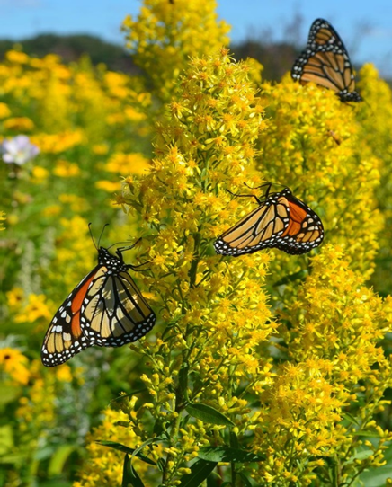

Photo 1: *solidago specioza*

(Source: <https://www.pinterest.com/pin/260645897179468650/>)

Have you ever looked around on a beautiful autumn day and noticed that some plants are still in bloom? Wouldn't autumn be more beautiful and colourful if more plants were in bloom? If you're a big fan of colourful, fairy-tale autumn, we can tell you that these are plants that harm both the environment and people.

Invasive species are organisms that have been introduced by humans into a new environment where they were not previously present. Most people are unaware of the problem of non-native species, because to them they are just colourful plants that "beautify" our environment. However, we need to be aware that non-native species can become a problem, as they can become invasive not only to native plants, but also to us humans.

People bring non-native species into the country, both intentionally and unintentionally. Some non-native species have been introduced by humans with the intention that the species would become accepted in the environment and that humans would benefit in some way. In Slovenia, there are still illegal intentional introductions of non-native species into nature. Plants that are unintentionally transported by transport, packaging or personal luggage are known as stowaways, as they are hidden and often escape border controls. These organisms are not necessarily illegal, but the transfer of certain organisms that do not comply with laws or regulations may represent an illegal act. The best-known non-native species in Kočevje are the Canadian goldenrod, the Himalayan Balsam, the Japanese knotweed, the common ragweed and the tall fleabane.

Invasive species can be removed in several ways. The most common are physical, biological and chemical removal. Physical removal simply involves pulling the plant out of the soil, the only downside is that it can be time-consuming and laborious.

Biological removal uses a natural predator of the invasive species to remove the original invasive species from the environment. This approach can be very risky as natural predators can become invasive species. Introducing another invasive species just to remove the original invasive species is not only risky, but can cause even more problems.

The last way to remove invasive species is chemical removal. Chemical removal uses pesticides to remove invasive species. When using chemicals, we need to be careful not to cause more problems in the environment, because using too much pesticide can be dangerous.

Invasive species can become a problem not only for native plants, but also for people. Buying and planting non-native species can put native plants at even greater risk. Non-native species can replace native plants by taking over their habitat, food and water. Because of the high "competition" of non-native species, many plants can become extinct. It is important not to bring unknown species from abroad, as they can become invasive or can carry a variety of diseases that can spread to humans.

Avtorici: Zala Oražem, Sara Oražem